

California State University of San Marcos

Jordan Fisher, Juan Gonzalez, Keith Gross, Miguel Morales , Noah Miera

CIS490 : Dr. Shaun-inn Wu

### Table of Contents

**Sushi Team -Team Norms**  4

1. **Application development**

1.1 Statement of Business Context 5

1.2 Statement of Customer’s Business Problem 5

1.3 Statement of Project Proposal 5

1.4 Statement of Deliverables 5

1.5 Measures of Success 6

1.6 System Overview 6

1. **Requirements Matrix** 7
2. **Project Management**

3.1 Product Breakdown Structure 8

3.2 Work Breakdown Structure 9

3.3 Initial Schedule for Tasks and Deliverables 10

3.4 Statement of Total Price 13

3.5 Gantt Chart (Phases 0-2 only -Due to technical difficulties) 14-15

3.6 Initial Project Cost Tracking Chart 15

3.7 Statement of Deliverables 16

3.8 Outline of Resources Needed 16

1. **Team - Appendix**

4.1 Access to Project 17

4.2 Attendance Records 17

4.3 Timesheet 18-19

4.4 Team Information 20-28

To: Jared Macshane, Machine Learning Supervisor

CC: Dr. Shaun-inn Wu, Director of Projects

The Sushi Team is grateful to be able to be part of this for Keep America Beautiful. Thank you Jared, as well as Dr. Wesley Schultz, for not only this opportunity to work in the Machine Learning field for this project, but also to work on something that helps build and maintain clean, green, and beautiful spaces in America. We look forward to working and learning from you this Spring semester of 2022, in order to assist in the making of this project.

In this first phase, the team went over documentation and code from TACO, a growing image dataset of waste in the wild, in which the images are labeled and segmented according to a hierarchical taxonomy to train and evaluate object detection algorithms. We are doing so in order to see if we can utilize a pre-trained model, and adapt it to our needs to categorize litter, rather than just indicating if it’s present. We have also connected to a Google Cloud server, in a Anaconda/Miniconda environment, to progress together in the creation of code necessary for this new machine algorithm. In the next coming phase, we will strive to develop a Python program that will run the TACO model on a raw single image, in order to get familiar with how the TACO model/code works, as we move towards a functional and usable Machine Learning algorithm that the Web App team can utilize, under Jared’s supervision.

Regarding the projected cost of this project, the Sushi Team has determined that we will “charge” a rate of $23 per hour per member of our team. With this rate in mind, we estimate the total cost of the project to come to a total of $8,900 which includes the total projected work hours of our team and the monthly cost of a Google Cloud server for the 4 months of development. Should alternative or additional become required, these costs will be updated accordingly.

By signing below, you hereby approve Sushi Team to continue working on the following project: Keeping America Beautiful: Litter Detective and agree to the aforementioned estimated costs.

__________________________________________________

Jared Macshane, Machine Learning Supervisor

### Sushi Team - Team Norms

● **On time:** Team members will arrive on time. If team members are unable to arrive on time, they will make an effort to notify the team. Absences for emergencies will be excused so long as the team and Professor Wu are made aware of them.

● **Respectful:** Team members will act respectfully towards each other and bullying, harassment, and similar forms of disrespect are prohibited.

● **Willing to learn:** Each team member will be asked to learn new information and skills to complete their work on this project. This learning will both be inside and outside of the classroom.

● **Open to help:** If a teammate is struggling with an aspect of their work, they are expected to ask for help. Similarly when asked for help, team members are expected to assist their teammate so long as they are reasonably able.

● **Communication:** General team communication will be done via the group’s Discord channel.

● **Quality:** Team members are expected to finish their tasks at the best quality possible, satisfying the client. If work is considered poor quality by the rest of the team, it will be redone.

### 1. Application Development

**1.1 Statement of Business Context**

Keep America Beautiful is a leading national nonprofit organization that inspires and educates people to take action every day to improve and beautify their community environment. They envision a country in which every community is a clean, green, and beautiful place to live.

**1.2 Statement of Customer’s Business Problem**

* Need a new Machine Learning algorithm to produce data on images containing litter.
* Needs the data to not only detect if there is litter, but also categorize them.
* Make the data available and usable for the Web App team.

**1.3 Statement of Project Proposal**

* 1. Process images through a pre-trained model.
* 2. Adapt model to our specific needs of litter detection.
* 3. Collect output data.
* 4. Sync up input/output format with the Web App team.
* 5. Make data accessible to the Web App team.

**1.4 Statement of Deliverables**

* Machine Learning code/algorithm that will be compatible and usable with the Web App team.
* Algorithm will produce data that will include:
  + Identification of litter in an image.
  + Categorize the litter (e.g. Plastic bottle, Paper bag).
  + Show the detection accuracy (e.g. 90% sure this is a Plastic bottle-Litter).

We will strive to deliver a new Machine Learning algorithm for Keep America Beautiful, developed through Python in a Anaconda/Miniconda environment, that will output usable and available data for the Web App team.

**1.5 Measures of Success**

The Sushi Team will perform the following tasks in order to accomplish the requirements listed in the proposal.

* JAD #1 - Identify initial requirements and technical specifications for the project.
  + Connect to a Google Cloud Server.
  + Establish Anaconda/Miniconda environment.
  + Read documentation/code of TACO’s pre-trained model.
  + Develop a program that runs the model on a raw single image.
* JAD #2 - Identify the final requirements and technical specifications for the project.
* Prototype #1 - Process images through the Machine Learning algorithm to produce litter metrics.
* Prototype #2 - Able to sync up the input/output format of the Machine Learning algorithm with the Web App team.
* Final Product - Collation and transfer of litter metrics from images, received by the Web App team, that have been processed through a Machine Learning algorithm, for use by the Web App team.

**1.6 System Overview**

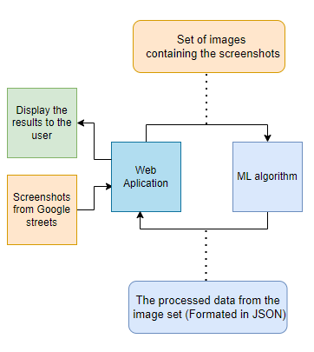

### 2. Requirements Matrix

| REQ # | Requirement name | Description | Critical | Implemented | Task ID |
| --- | --- | --- | --- | --- | --- |
| 1 | Adapt TACO | Before the TACO dataset can be used, it must be adapted to the needs of the web app | Y | N | 4.5.1 / 4.5.4 / 5.2.2 / 5.2.6 |
| 2 | Process Images | Ensure that the ML algorithm can process image datasets | Y | N | 5.5.1 / 5.5.6 / 6.2.2 / 6.2.9 |
| 3 | Schedule Hook | Ensure that the web app team can schedule the ML algorithm and it can receive the set of images | Y | N | 6.5.2 |
| 4 | Prepare Image Data | The ML program will process the algorithm’s results based on the needs of the web app team | Y | N | 6.5.8 / 7.2.2 |
| 5 | Send Prepared Data | Once the data has been prepared, the program will deliver the data to the web app | Y | N | 7.2.9 / 7.2.15 |

### 3. Project Management

**3.1 Product Breakdown Structure**

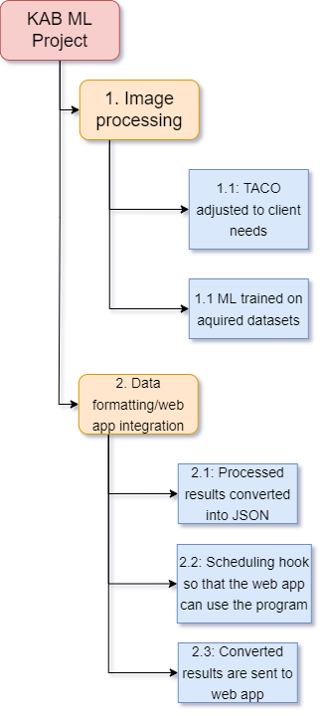

**3.2 Work Breakdown Structure**

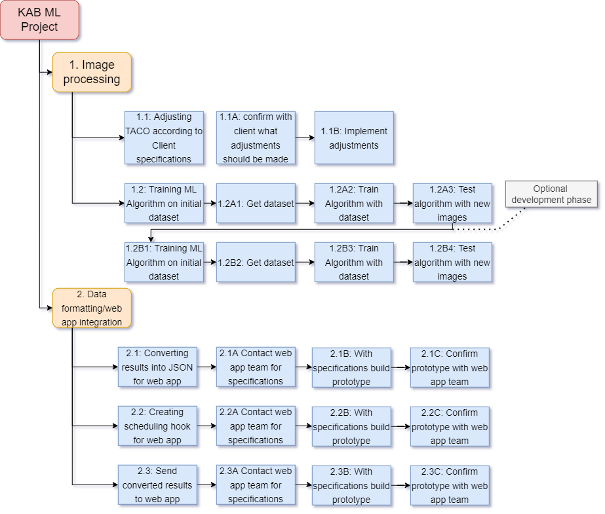

**3.3 Initial Schedule for Tasks and Deliverables**

List of Tasks

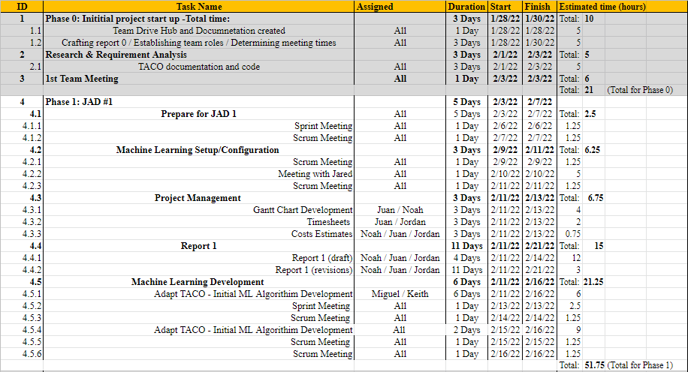

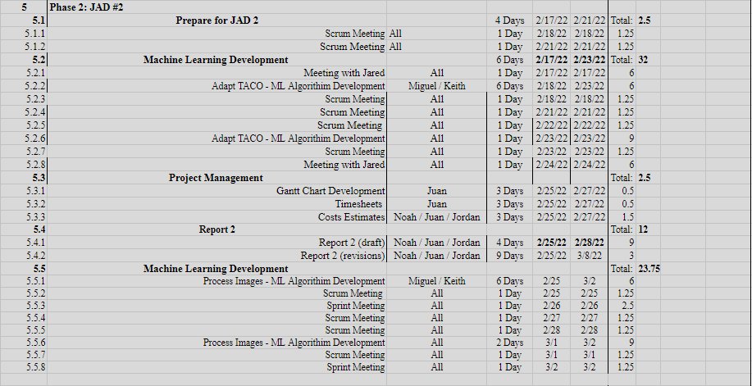

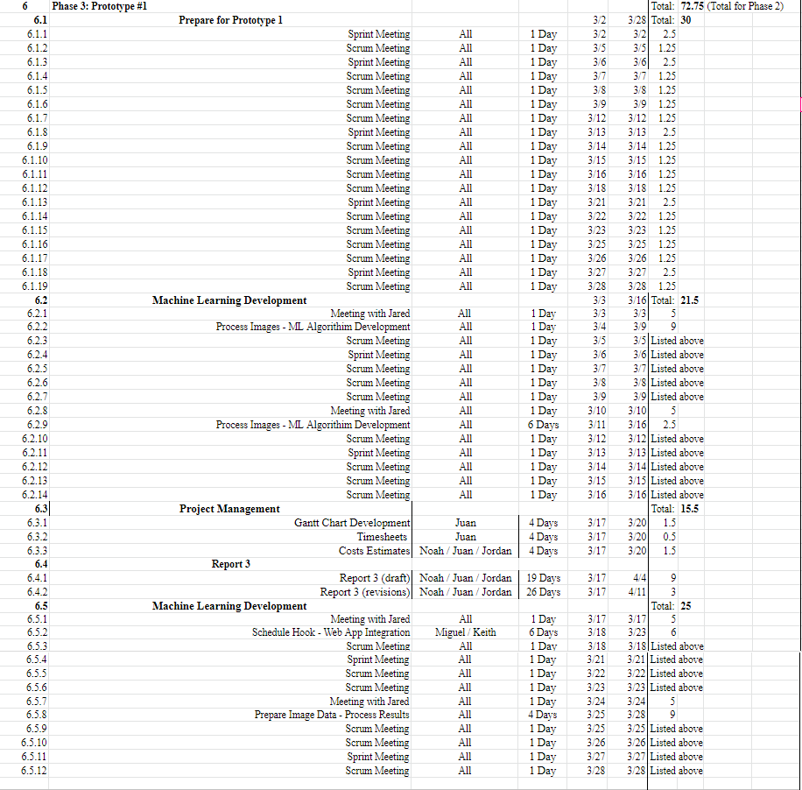

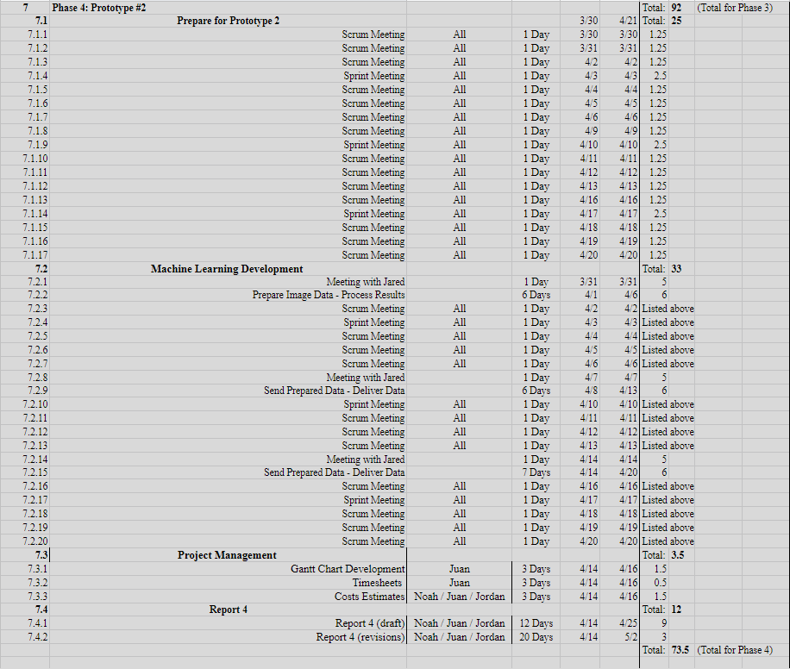

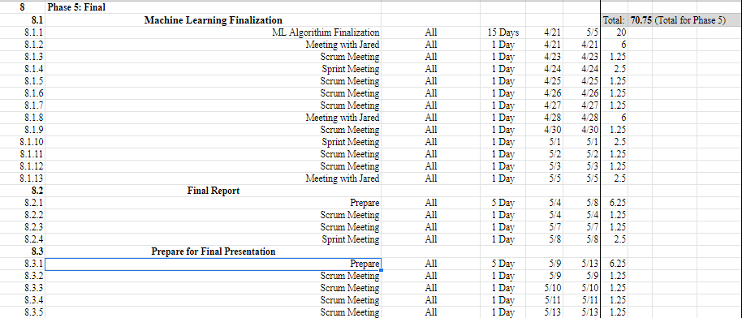

**3.4 Statement of Total Price**

As stated in the cover letter, Sushi Team has determined that we will “charge” a rate of $23 per hour per member of our team. With this rate in mind, we estimate the total cost of the project to come to a total of $8,900 which includes the total projected work hours of our team and the monthly cost of a google cloud server for the 4 months of development. Should alternative or additional become required, these costs will be updated accordingly.

**3.5 Gantt Chart (Phases 0-2 only - Due to technical difficulties)**

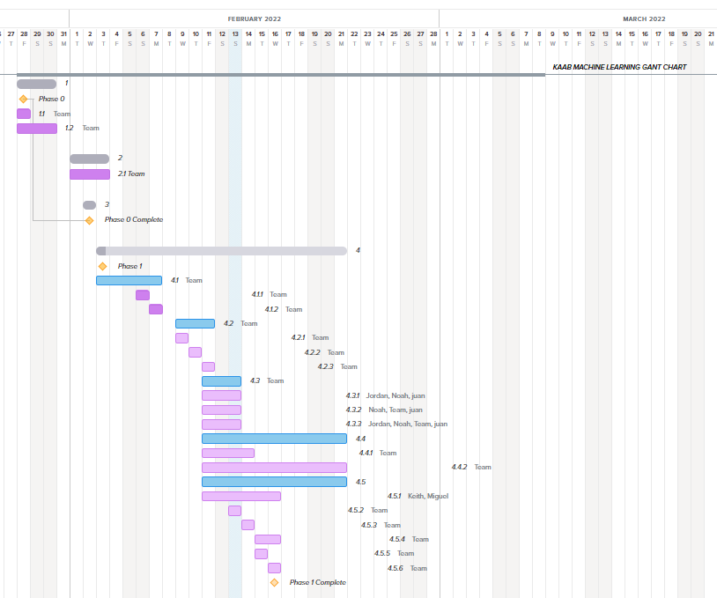

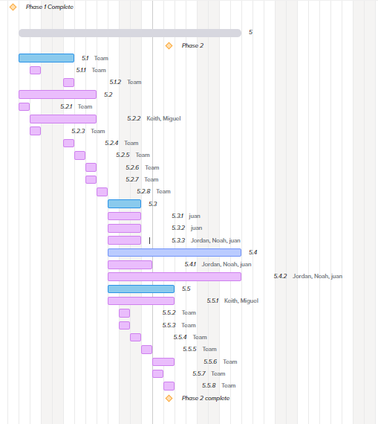

Note: Online environment required a premium subscription to include additional tasks to be included within the same project which led to us including the maximum tasks it allows so can display at least part of our Gantt chart showing up until phase 2. Will include a full one in the Final report.

**3.6 Initial Project Cost Tracking Chart**

(As of now)

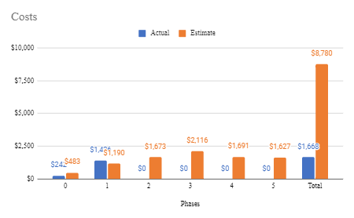

The above chart tracks the estimated and actual costs for each phase of the project as well as our total accumulated costs compared to our estimated costs. We will assume an hourly rate of $23.00 per hour for this project.

**3.7 Statement of Deliverables**

The Sushi Team strives to deliver the following final products:

* A fully working machine learning algorithm that will detect instances of litter in an image and identify the type of each instance.
* A scheduling hook by which the web app team can use this algorithm by sending a set of images.
* A system to format the data collected from the set of the set of images sent using the web application.
* A system to send the formatted data back to the web application for further use as determined by the web app team.

**3.8 Outline of Resources Needed**

The following are what the Sushi Team will be supplying:

* Knowledge of Python code, documentation, and implementation.
* Updated documentation.
* Research and testing.

The following resources are what the Sushi Team will need supplied from Jared Macshane:

* Source code from the TACO model (Pre-trained ML model).
* Google Cloud Server Instance and Funding.
* Signage and approval for the Sushi Team to continue working on the project.
* Availability for future meetings.

### 4. Team - Appendix

**4.1 Access to Project**

The following will be how the Sushi Team will be collarbaring during this project so-far:

* Google Drive.
* Discord.
* Google Cloud Server Instance.
* GitHUB

**4.2 Attendance Records**

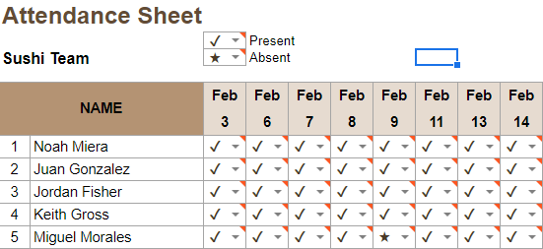

**4.3 Timesheets**

**Week 2**

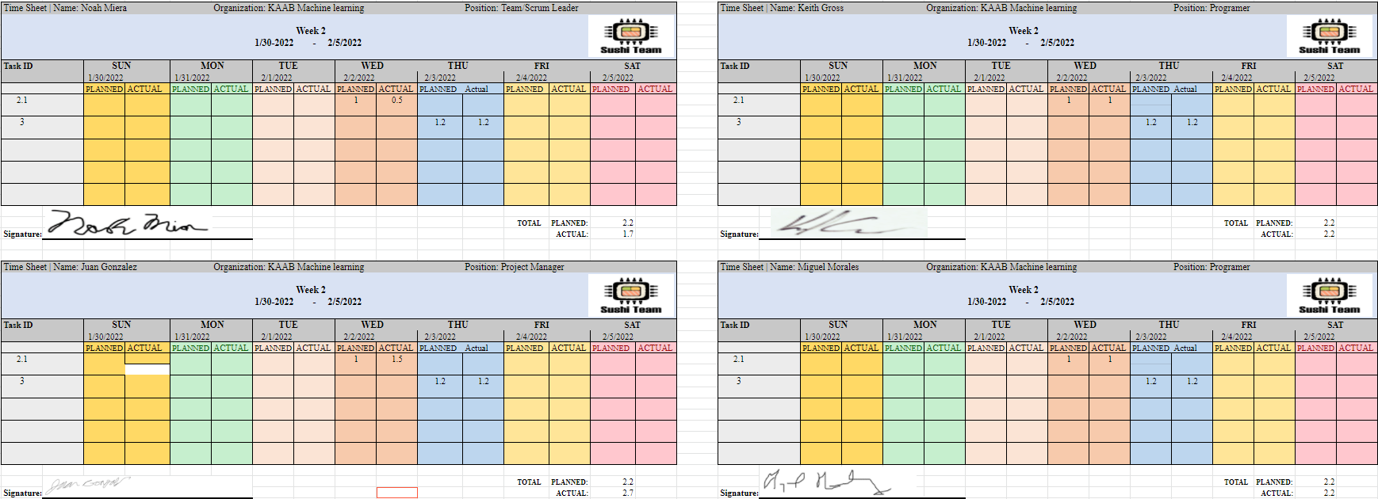

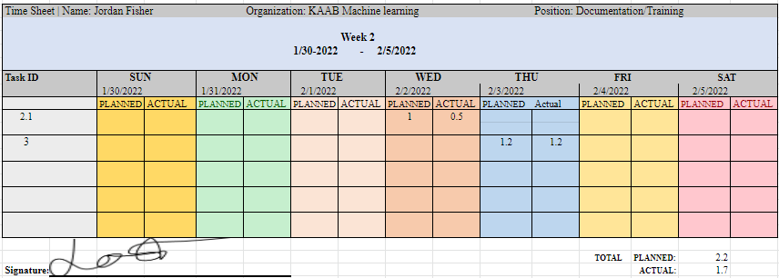

**Week 3**

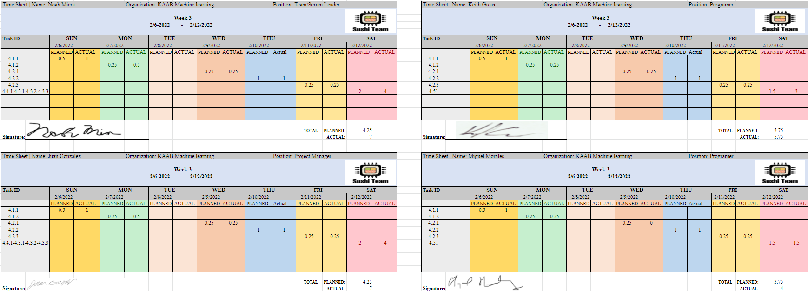

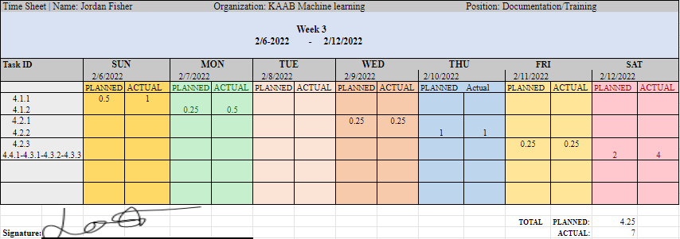

**Week 4**

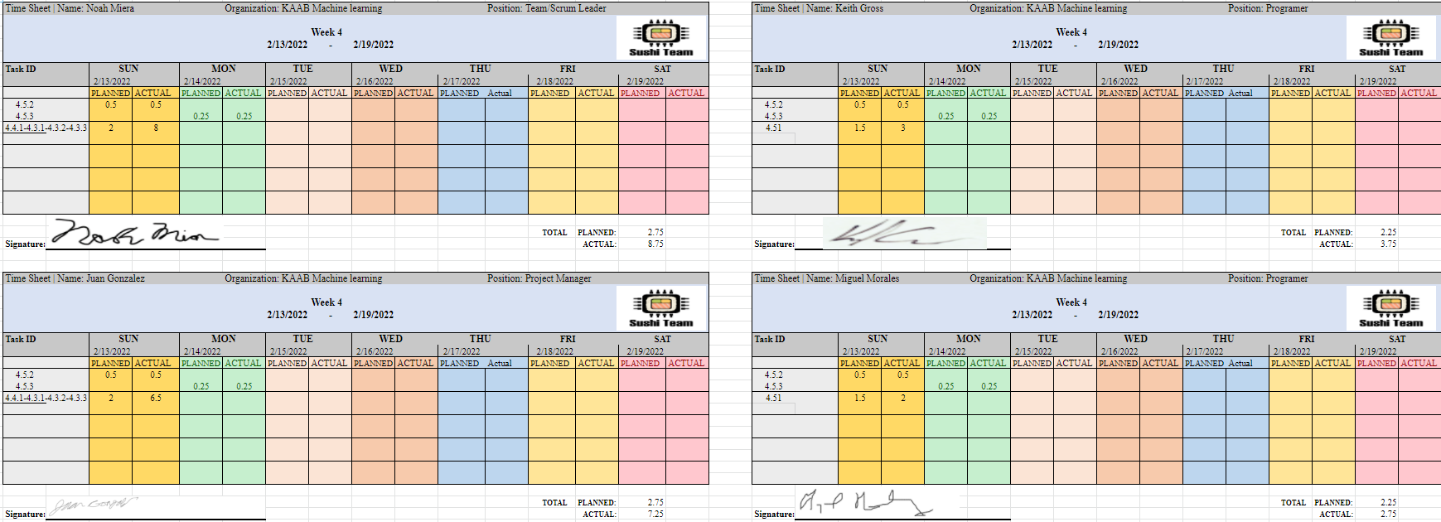

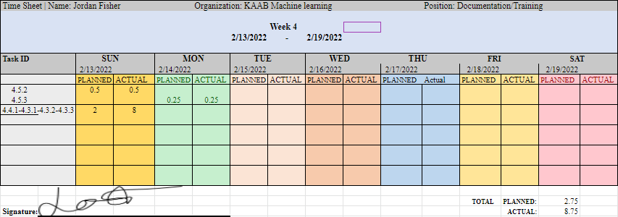

**4.4 Team Information**

|  | Noah Miera  Team/Scrum Leader  While I do not have experience working in Machine Learning, or Object Detection before, I do have experience working in Python, the language for this project, according to Jared. I believe I will work well as Team/Scrum Leader, due to me being in similar positions for other past school projects, non-school events, and work. I will strive to maintain continuity and consistency throughout this project. |
| --- | --- |
|  | Juan Gonzalez  Project Manager  I have worked on two machine learning based projects in the past where I understood that cleaning up a data set is essential to acquiring desired outcomes. I’ve solely worked with numerical data when implementing machine learning and have not worked with image processing. My experience working with Sushi Team as Project Manager has involved high amounts of communication among the team in order to organize and manage tasks to meet requirements. Taking advantage of modern Project managing apps will be key to our success. |
|  | Jordan Fisher  Documentation/Training  My primary contribution to the Sushi team is ensuring that the team lead and project manager have access to clean organized information and creating accurate and descriptive diagrams to better communicate said information. In my scholastic and professional life I have filled similar roles such as in the numerous group projects where I took on such responsibilities. |

|  | Keith Gross  Programmer  My background working in Test Engineering and the U.S. Navy has provided me with the skills needed to develop solutions for complex problems I may not have a background in. While I don’t have a background in Machine Learning I am able to find the resources we need to develop our machine learning algorithm and program, program a solution, then resolve any issues that present themselves during our test cases. |
| --- | --- |
|  | Miguel Morales  Programmer  Miguel Morales is a programmer for Sushi Team. Mr Morales has experience in several programming languages such as C/c++, Java and Python. The programming role is well suited because of his adaptability skills to learn and approach computer problems. |

* Write paragraphs explaining the experience of team members relevant to the project.
* Identify the major role that each team member on the team will play and explain why that person is well suited to that role.
* Include team photograph(s) with names.
* Include a resume for each team member.

**Resumes**



